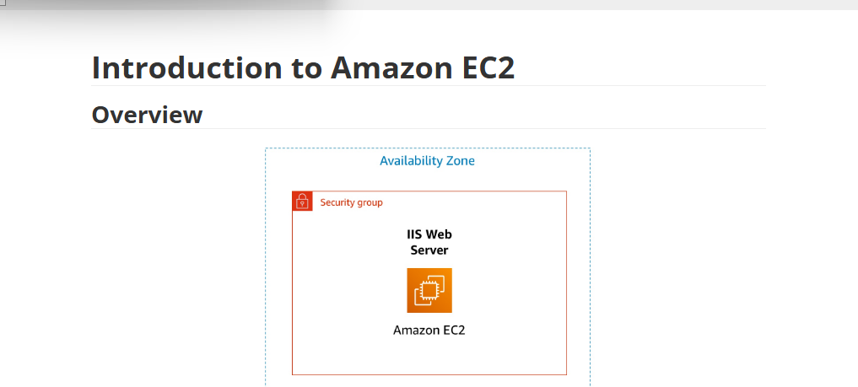
The First phase of Completing an Ec2 instance Starts in the Lab….
Click-“Start Lab’

